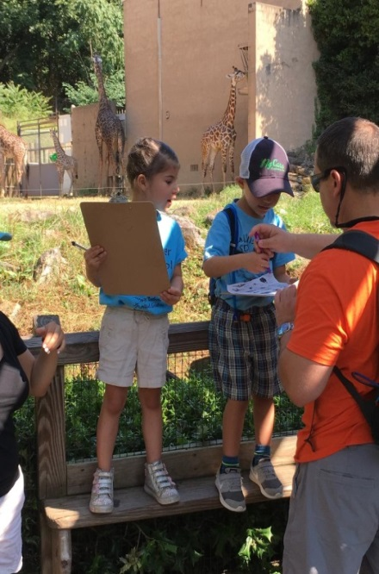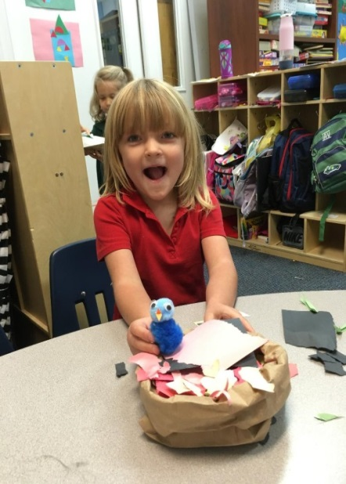

**Students took a field trip to the Greenville Zoo and enjoyed finding different animals that were on their clipboard.**

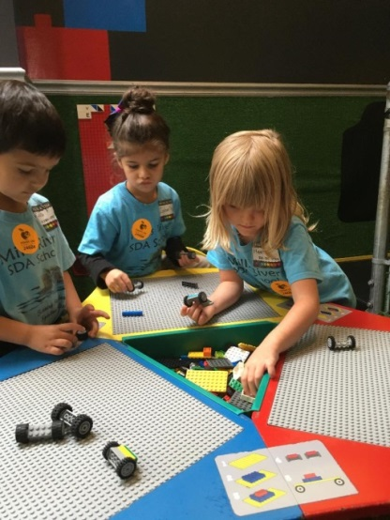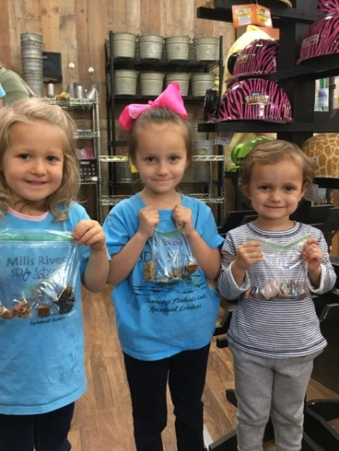

**Kindergarteners had a blast at the Pisgah Gem Mine learning about rocks and minerals!!**

**Students creating cars to send down the ramp at the Hands On! Museum in Hendersonville.**

**A Day in Kindergarten**

**Students enjoyed learning about animal homes, and created a bird’s nest.**